**Department/Discipline Description**: Popular Reading (Fund 34365)

**Subject Librarian:** Rebecca Boughan

**Annual Budget Allocation:** $4,809.00

**Overview:**

The library seeks to support recreational reading as well as the use of popular literature to benefit students both in and out of the classroom.

**Research interests:**

The Popular Reading collection is designed to collect a sampling of current literature from a variety of genres. Collection development is based on patron demand as measured through circulation statistics. Emphasis is also given to what is popular among the general population through lists such as the New York Times Bestsellers and others.

**Departments/Disciplines/Programs/Subject Areas:**

The primary genres collected are:

Biography

Classics

Fantasy

General Fiction

Graphic Novels

Humor

Mormon

Motivational

Mystery

Nonfiction

Romance

Science Fiction

Western

**Subject Librarian Annual Collections Report** - **2016**

- 494 new books added to the collection (67 additional ordered in 2016 but listed on 2017 fund report)

- In 2016 there were a total of 42,595 circulations from the Sampler collection. This represents an increase of 4,984 over 2015.

Circulation Data by Year Purchased

-1946 checkouts of books added in 2014, 51/551 books purchased in 2014 have not yet received any use

-1224 checkouts of books added in 2015, 90/572 books purchased in 2015 have not yet received any use

-242 checkouts of books added in 2016, 295/494 books purchased in 2016 did not receive use before the end of 2016 (many of these were not processed until 2017 and 68 are still unprocessed)

**Subject Librarian Annual Collections Report** - **2015**

- 572 new books added to the collection

- In 2015 there were a total of 37,611 circulations from the Sampler collection. This represents an increase of 17,320 over 2014.

**Program assessments and changes**:

The fantasy genre receives the most circulation from BYU patrons. This reflects the current popularity of fantasy in literature, as well as other media, in the general population as well. The graphic novel collection continues to increase in popularity and amounts to a surprisingly large amount of the check outs considering the relatively small size of the collection. This area warrants further development. The Western genre seems to be fairly outdated for a "Popular Reading" collection and is receiving less than 400 checkouts per year for the entire section (less than 1% of total usage). It may be time to stop collecting in this area and possibly change up the configuration of the physical area. Although the World Classics are shelved in the Popular Reading area, they have regular LC call numbers and do not show up in the SAMP circulation report. Additionally, since Classics are by definition older materials, this is a static collection and does not warrant additional development (although materials are still evaluated for replacement when damaged). The Romance collection is one where the tastes of the general populace cannot be used to guide selection decisions and care must be taken to ensure that materials purchased are appropriate to our collection. Although I am not actively weeding previously purchased titles, the titles added to the collection since I took over are all classified as "clean romance" and will support the desires of students looking for wholesome and romantic reading material. The bulk of the usage in the Mormon collection is for Mormon romance novels that meet this criteria and I believe that adding this facet to the Romance collection will only increase usage there. We are collecting Mormon materials from every LDS approval vendor in the general stacks and in Special Collections. So as to maximize the budgeted funds by limiting duplication, I have begun selecting Mormon materials from self-published works. In all cases so far, these self-published works are from LDS authors who have had at least one work published by a mainstream LDS publishing house, but who have branched out on their own (or with a group of other LDS authors) to publish their own books going forward. There was a session at ULA a few years ago where several well-known LDS authors spoke about how they see the future of LDS publishing is self-publishing and many are not even trying to go the traditional route any longer.

A recent report stated that 93% of Sampler material has been used at least once since purchased. I was interested in why the other 7% was not used. From my analysis, the large majority of unused titles are either just received and have not yet had time to be discovered or are still unprocessed and so not really available to be used (Scott excluded unprocessed from his report so these are not part of the 7%, but unprocessed material was included in the report I received from his student). I will be taking a closer look at the unused titles from 2014 and 2015 to see if there are any patterns which indicate material which is less desirable to our patrons.

Unprocessed – 33% of unused (135 from 2016, 43 older materials still unprocessed)

2016 Books – 41% of unused (4.3% of the 7%)

2015 Books – 16% of unused (1.7% of the 7%)

2014 Books – 9% of unused (0.9% of the 7%)

Material older than 2014 – 1% of unused (0.1% of the 7%)

**Relation to OverDrive**

The 34365 budget supports the acquisition of physical materials in the areas listed above. Online books for a popular audience are purchased through the OverDrive database which is separately funded. A brief report on OverDrive is included herein to provide a more complete picture of all books related to the collecting areas. Additional subjects, such as Juvenile, are available through OverDrive as well. The following two graphs show that usage continues to increase, more users are making use of OverDrive, and audiobooks are a bit more popular than their ebook counterparts.

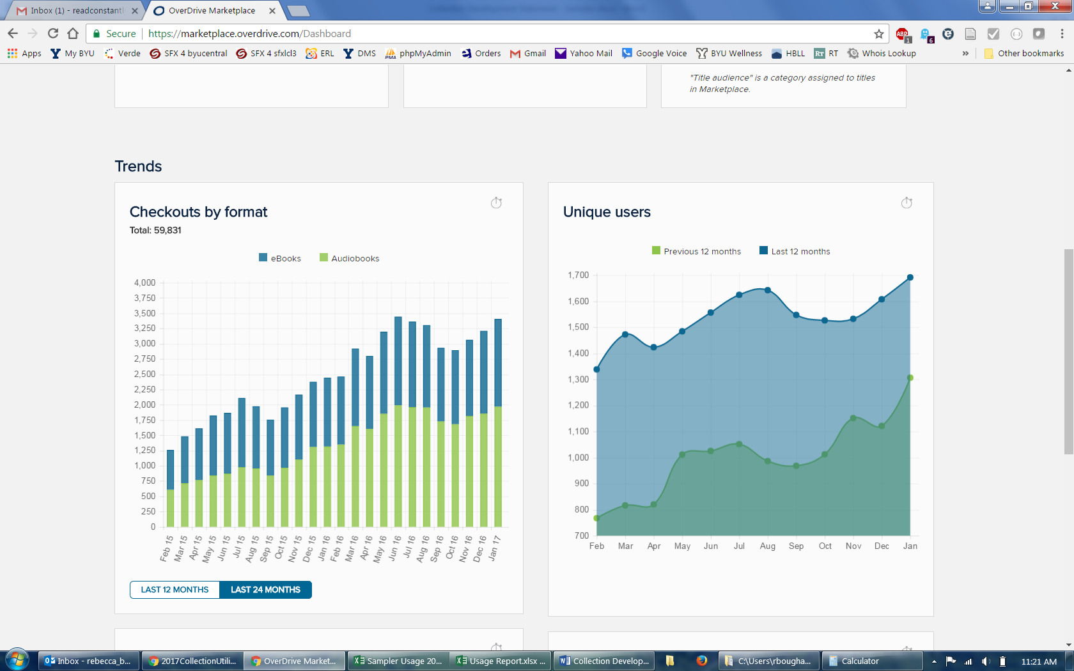

During 2016, OverDrive had 5,377 checkouts and 5,602 holds placed on materials. The five most popular titles during 2016 demonstrate the variety of material available. The most popular title, Harry Potter and the Cursed Child, is to be expected with the anticipation surrounding a new chapter in the Harry Potter saga. The second title, Me Before You, demonstrates the demand for the book version of movies released during the year. Titles 3 and 5 indicate that nonfiction definitely has an audience. Number 4 was purchased by Rachel Wadham and shows the patron desire for Juvenile/YA material.

|  |  |  |  |
| --- | --- | --- | --- |
| Title | Genre | Format | Checkouts + Holds |
| Harry Potter and the Cursed Child | Juvenile Fiction | eBook | 489 |
| Me Before You | Adult Fiction | eBook | 395 |
| The Power of Habit: Why We Do What We Do in Life and Business | Adult Nonfiction | Audiobook | 277 |
| The Shadow Throne: Ascendance Trilogy, Book 3 | Juvenile Fiction | Audiobook | 219 |
| Good to Great: Why Some Companies Make the Leap...And Others Don't | Adult Nonfiction | Audiobook | 189 |

Going forward, OverDrive collecting areas will remain the same: all Deseret Book/Shadow Mountain titles; popular titles tied to movie releases; popular nonfiction material, especially in audiobook format; other popular titles, especially in audiobook format; and Juvenile/YA materials.